Sample Submission and Tracking

Instructions for User Registration and Sample Submission
You can submit samples and track their progress on our laboratory information management system (LIMS or MiniLIMS).

- Click on “Sample Submission” from the top menu of our Home Page
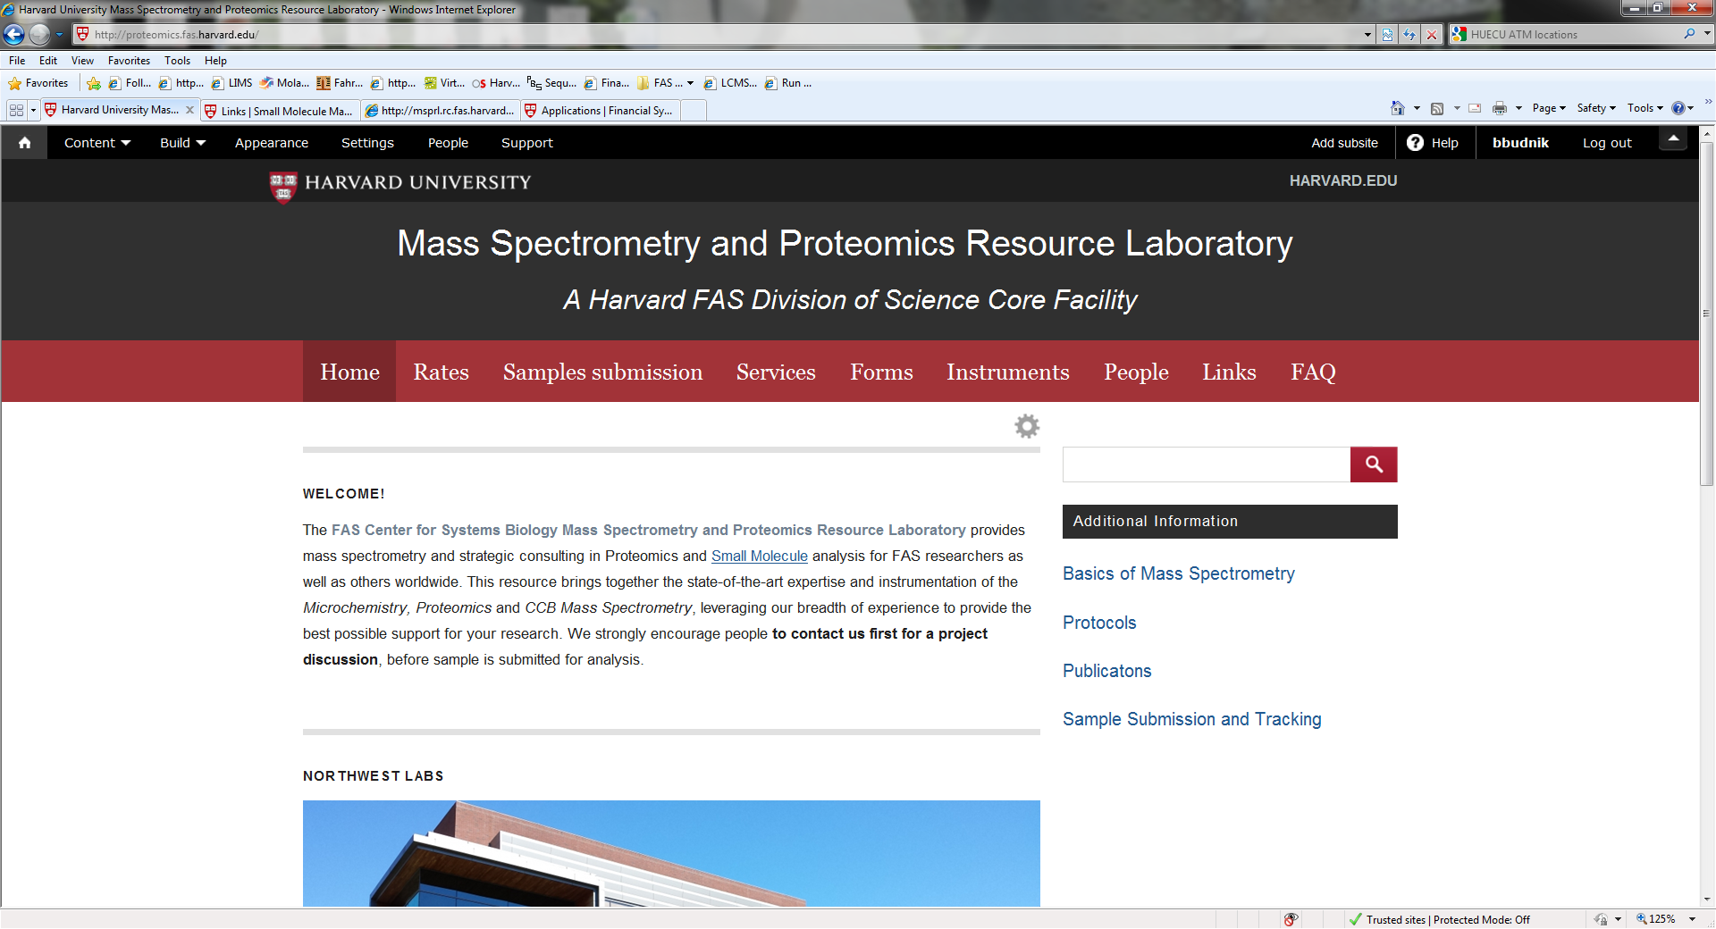
- If you have previously logged into our site enter your Username and Password

- If you have not previously logged into our system then click on “[New users register here]” found below the Harvard Seal at the bottom of the page.

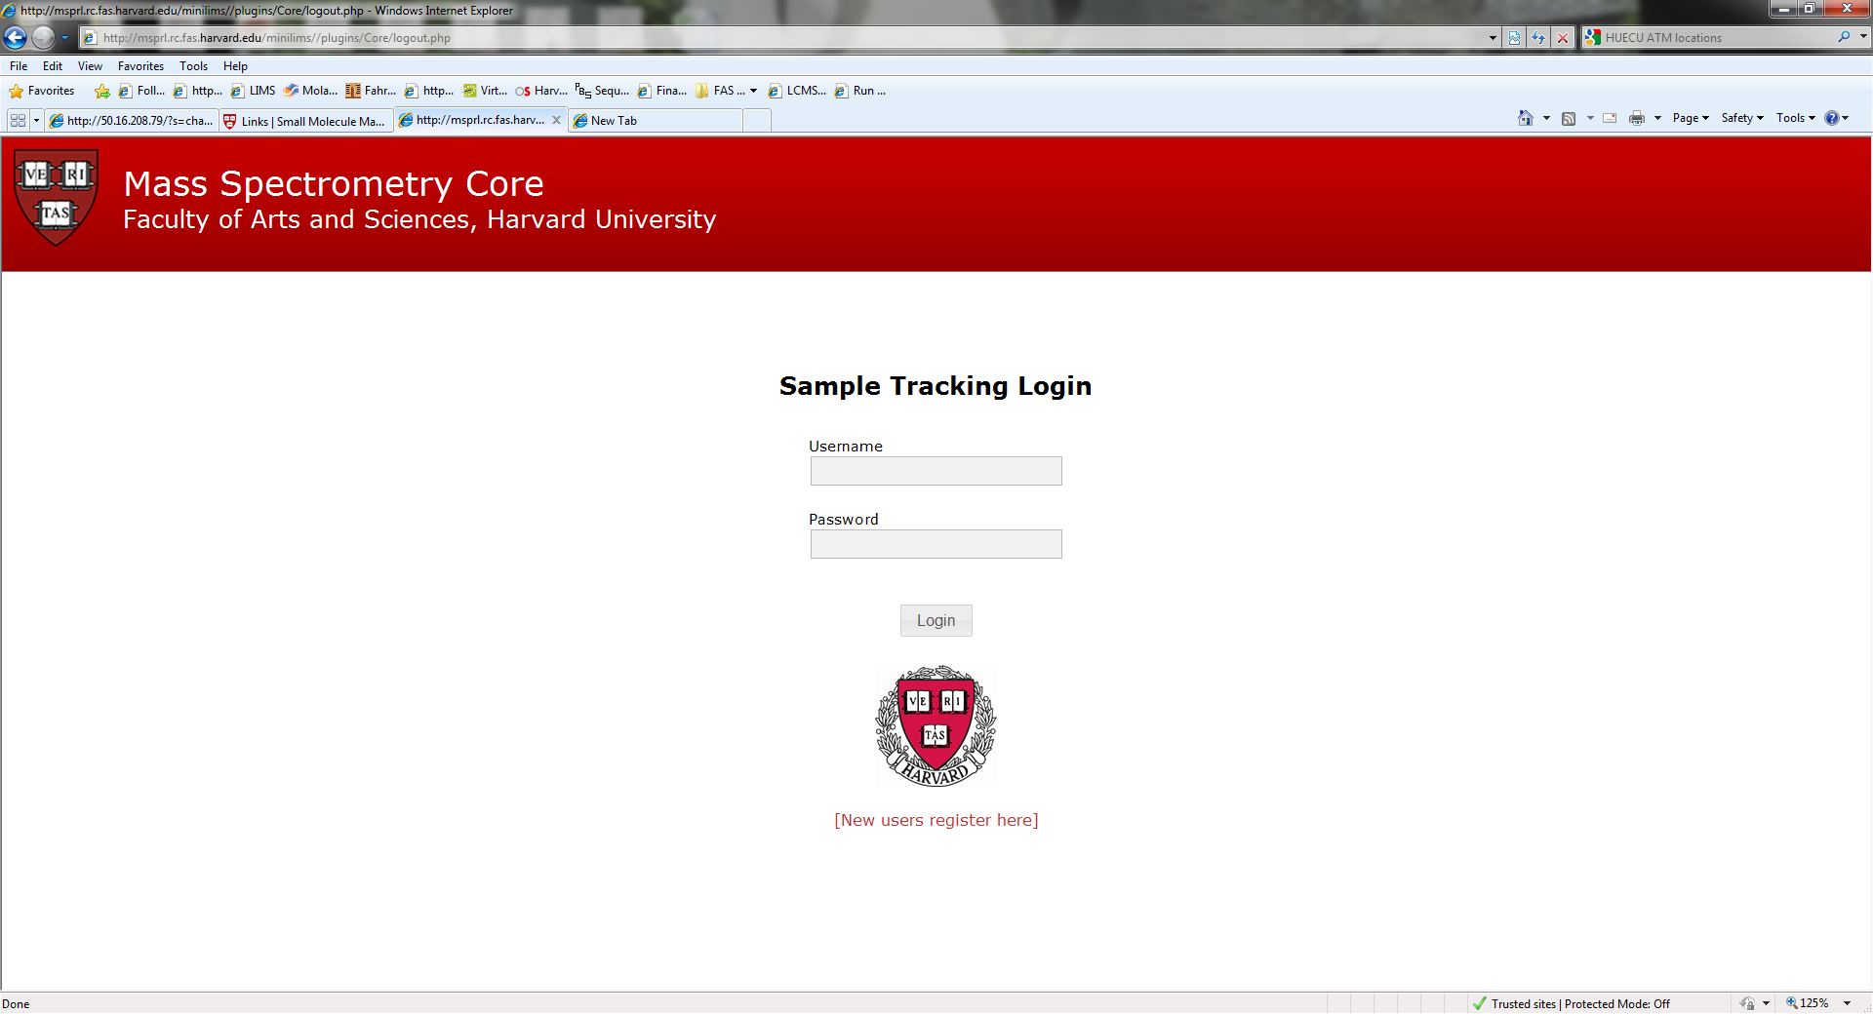

- This will take you to the registration page. Please fill in all the boxes and hit the submit button.

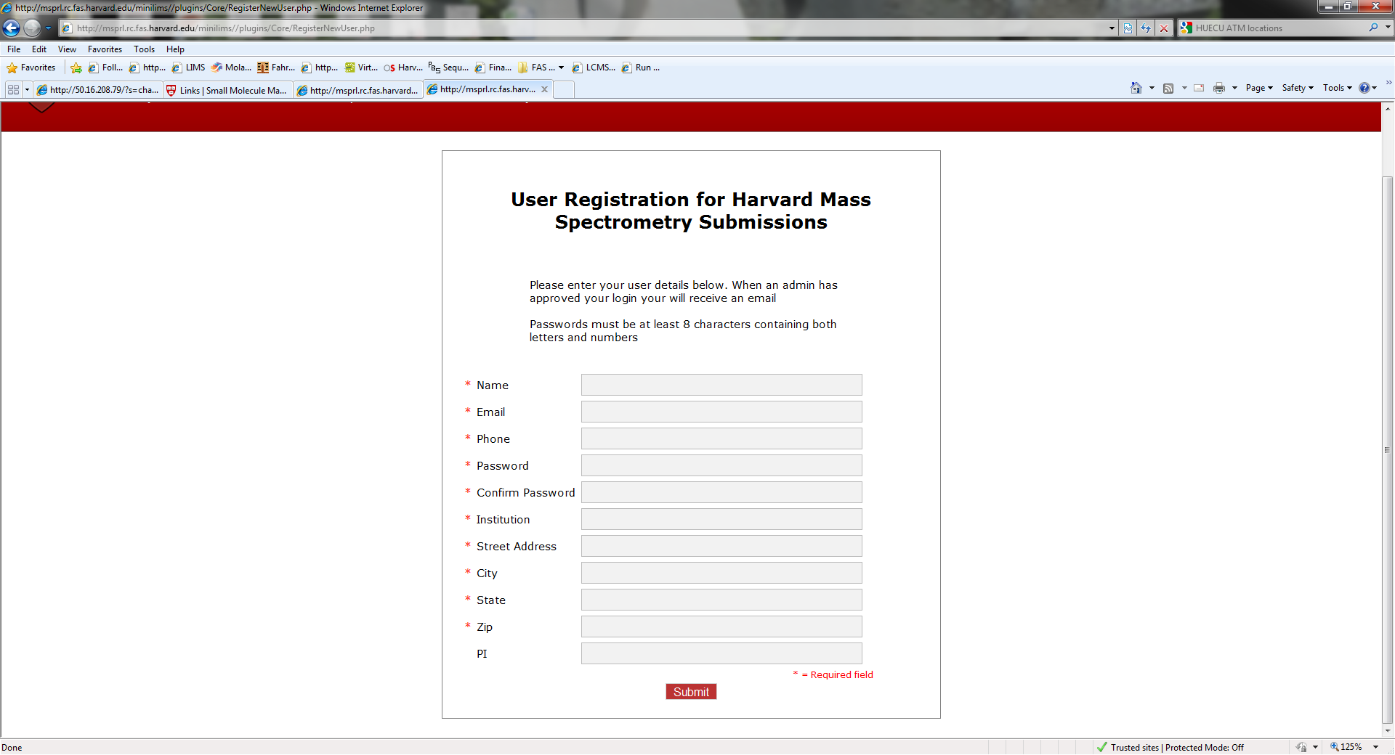
Note: Once your information has been reviewed by the administrator of the site, you will be entered in as a valid user. This is typically very quick! Once registered, you can simply login to the webpage for our sample tracking and login with your user information and password.

Instructions for Electronic Sample Submission
- Once you have registered and have a login and password, when you log in, you will see your home page which has a menu on the left and all previous samples listed.
- Click "request analysis" from the menu on your left to submit a new sample and enter its relevant information.
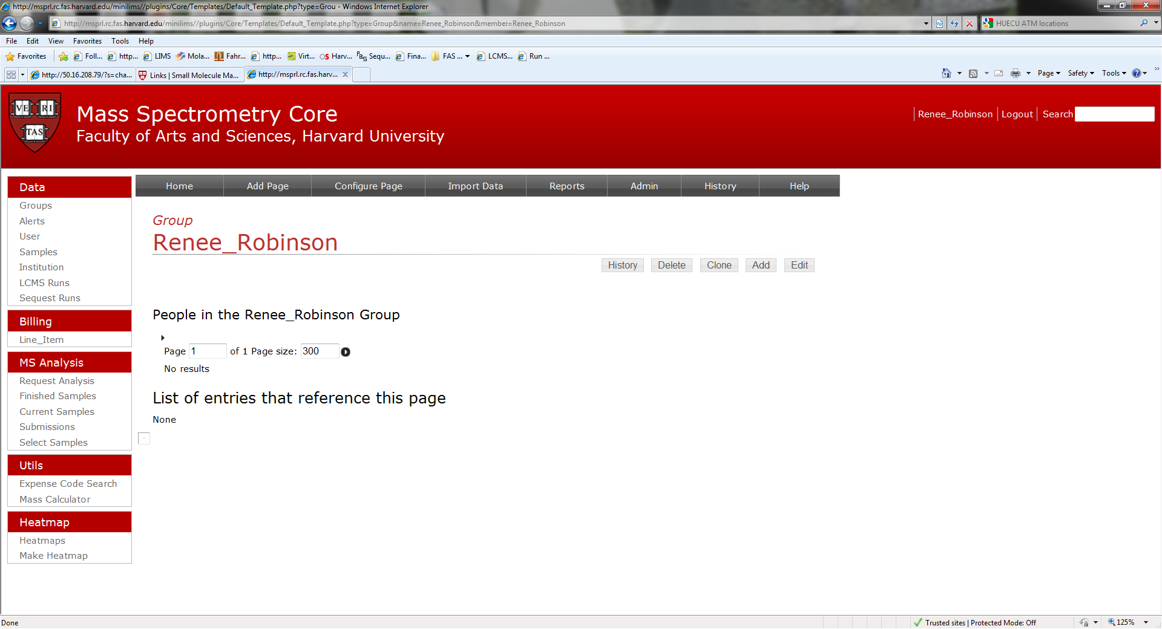

- Clicking on Request Analysis will allow you to add a submission. You can copy and add more submissions, keeping the basic information and just changing the name and MW and other variables by clicking the Add Sample button circled in red.
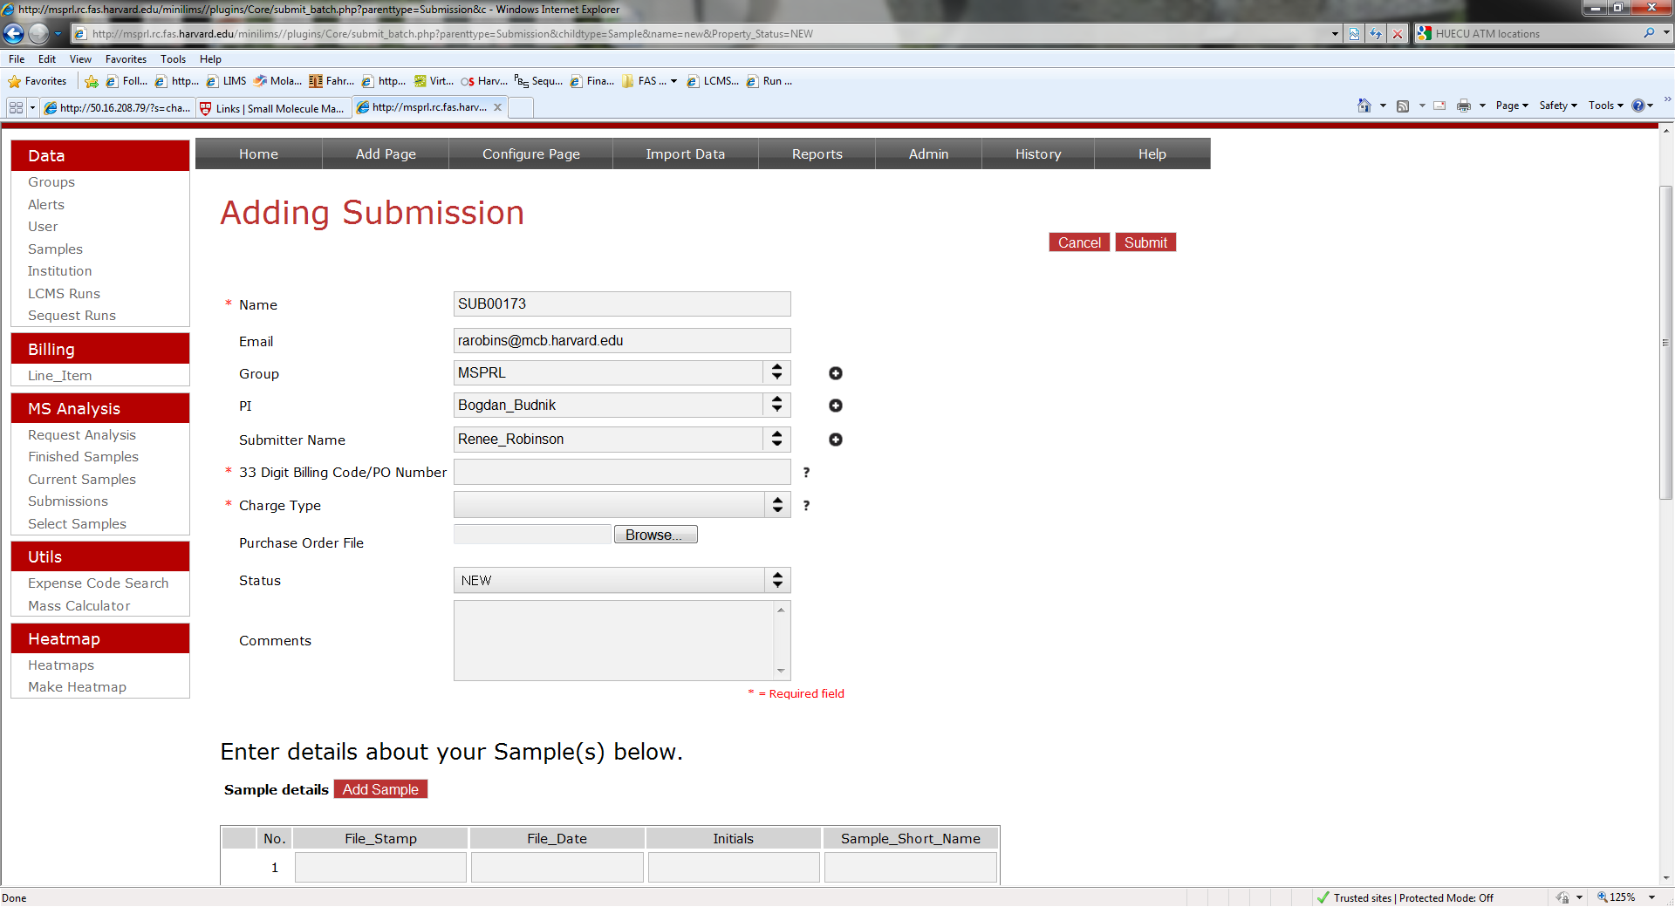
- You will be required to enter either a Purchase Order (outside Harvard users) or a 33 digit HARVARD code (for inside users). If you are submitting a PO then you are also required to upload a copy or .pdf of the PO document. We will not be able to begin work without this copy of the official PO. This PO must have our correct billing address. It must be a close approximation of the following address with the building, street address and room # being essential:

Harvard University
FAS Center for Systems Biology
Northwest Building B227.20
52 Oxford Street
Cambridge, MA 02138
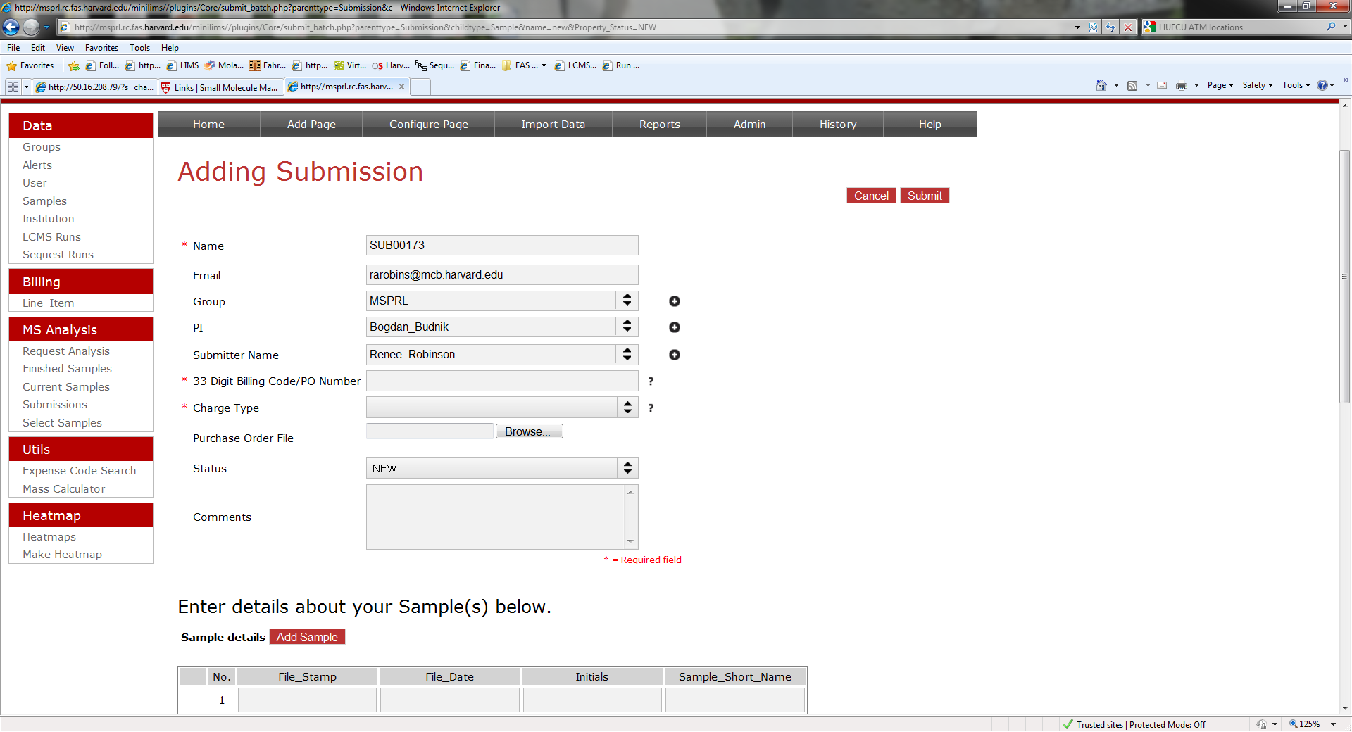
- Please contact us if you have any further questions using “sample submission” in the subject (proteomics@fas.harvard.edu).
- You will then print out a copy of the form(s) to send with your sample(s). If you are not bringing your samples to the lab yourself then send your samples on dry ice to the following address:
Harvard University
MSPRL
Northwest Building B247
52 Oxford Street
Cambridge, MA 02138

